**Estate Vista - A Real Estate MERN Stack project**

The Estate Vista project is a dynamic and feature-packed platform designed to redefine how users interact with property listings. Leveraging the MERN (MongoDB, Express.js, React, Node.js) stack, this project seamlessly integrates modern technologies to create a robust and user-friendly experience. The Real Estate website project aims to set new standards in the real estate industry by offering a modern, intuitive, and secure platform for users to explore, inquire, and engage with property listings. Whether you are a potential buyer, seller, or administrator, this project caters to diverse users, providing a seamless and enjoyable real estate experience.

**Design Document**

**Technology Stack**

**Frontend**

* **React.js**: The front end of the real estate website will be built using React.js, leveraging its component-based architecture for creating dynamic user interfaces.
* **React Router**: React Router will handle client-side routing, enabling navigation between different pages of the website without full page reloads.
* **Redux:** Redux will be used for state management, providing a predictable and centralized state container for the application. This will facilitate data sharing and communication between React components.
* **Tailwind CSS**: Tailwind CSS will be used for styling the website. Its utility-first approach allows for rapid development and customization of the user interface.
* **Axios**: Axios will handle HTTP requests from the frontend to the backend API, facilitating data fetching and interaction with the server.

**Backend**

* **Node.js**: The backend of the website will be powered by Node.js, allowing for the development of scalable and efficient server-side applications using JavaScript.
* **Express.js**: Express.js will handle routing, middleware, and HTTP requests on the server side, providing a robust foundation for building RESTful APIs.
* **MongoDB**: MongoDB will store data for the real estate website. Its flexibility and scalability make it suitable for storing various types of data, including user profiles, property listings, and related information.
* **Mongoose**: Mongoose will simplify interactions with the MongoDB database, providing schema validation and modeling capabilities.

**Authentication and Authorization**

* **Google OAuth**: User authentication will be implemented using Google OAuth for secure login and registration.
* **JWT (JSON Web Tokens)**: JSON Web Tokens will be used for authentication and authorization purposes, enabling access to protected routes and resources.

**Image Storage**

* **Cloudinary:** Cloudinary will be used for storing and serving property images. Its cloud-based infrastructure provides scalability and performance benefits for handling image uploads and storage.

**Deployment**

* **Vercel**: The real estate website will be deployed on Vercel, leveraging its seamless integration with the MERN stack, continuous deployment capabilities, and serverless architecture.
* **GitHub**: The website's source code will be hosted on GitHub for version control and collaboration, enabling automated deployments to Vercel.

**Database Schemas**

Using MongoDB for storing data on the website.

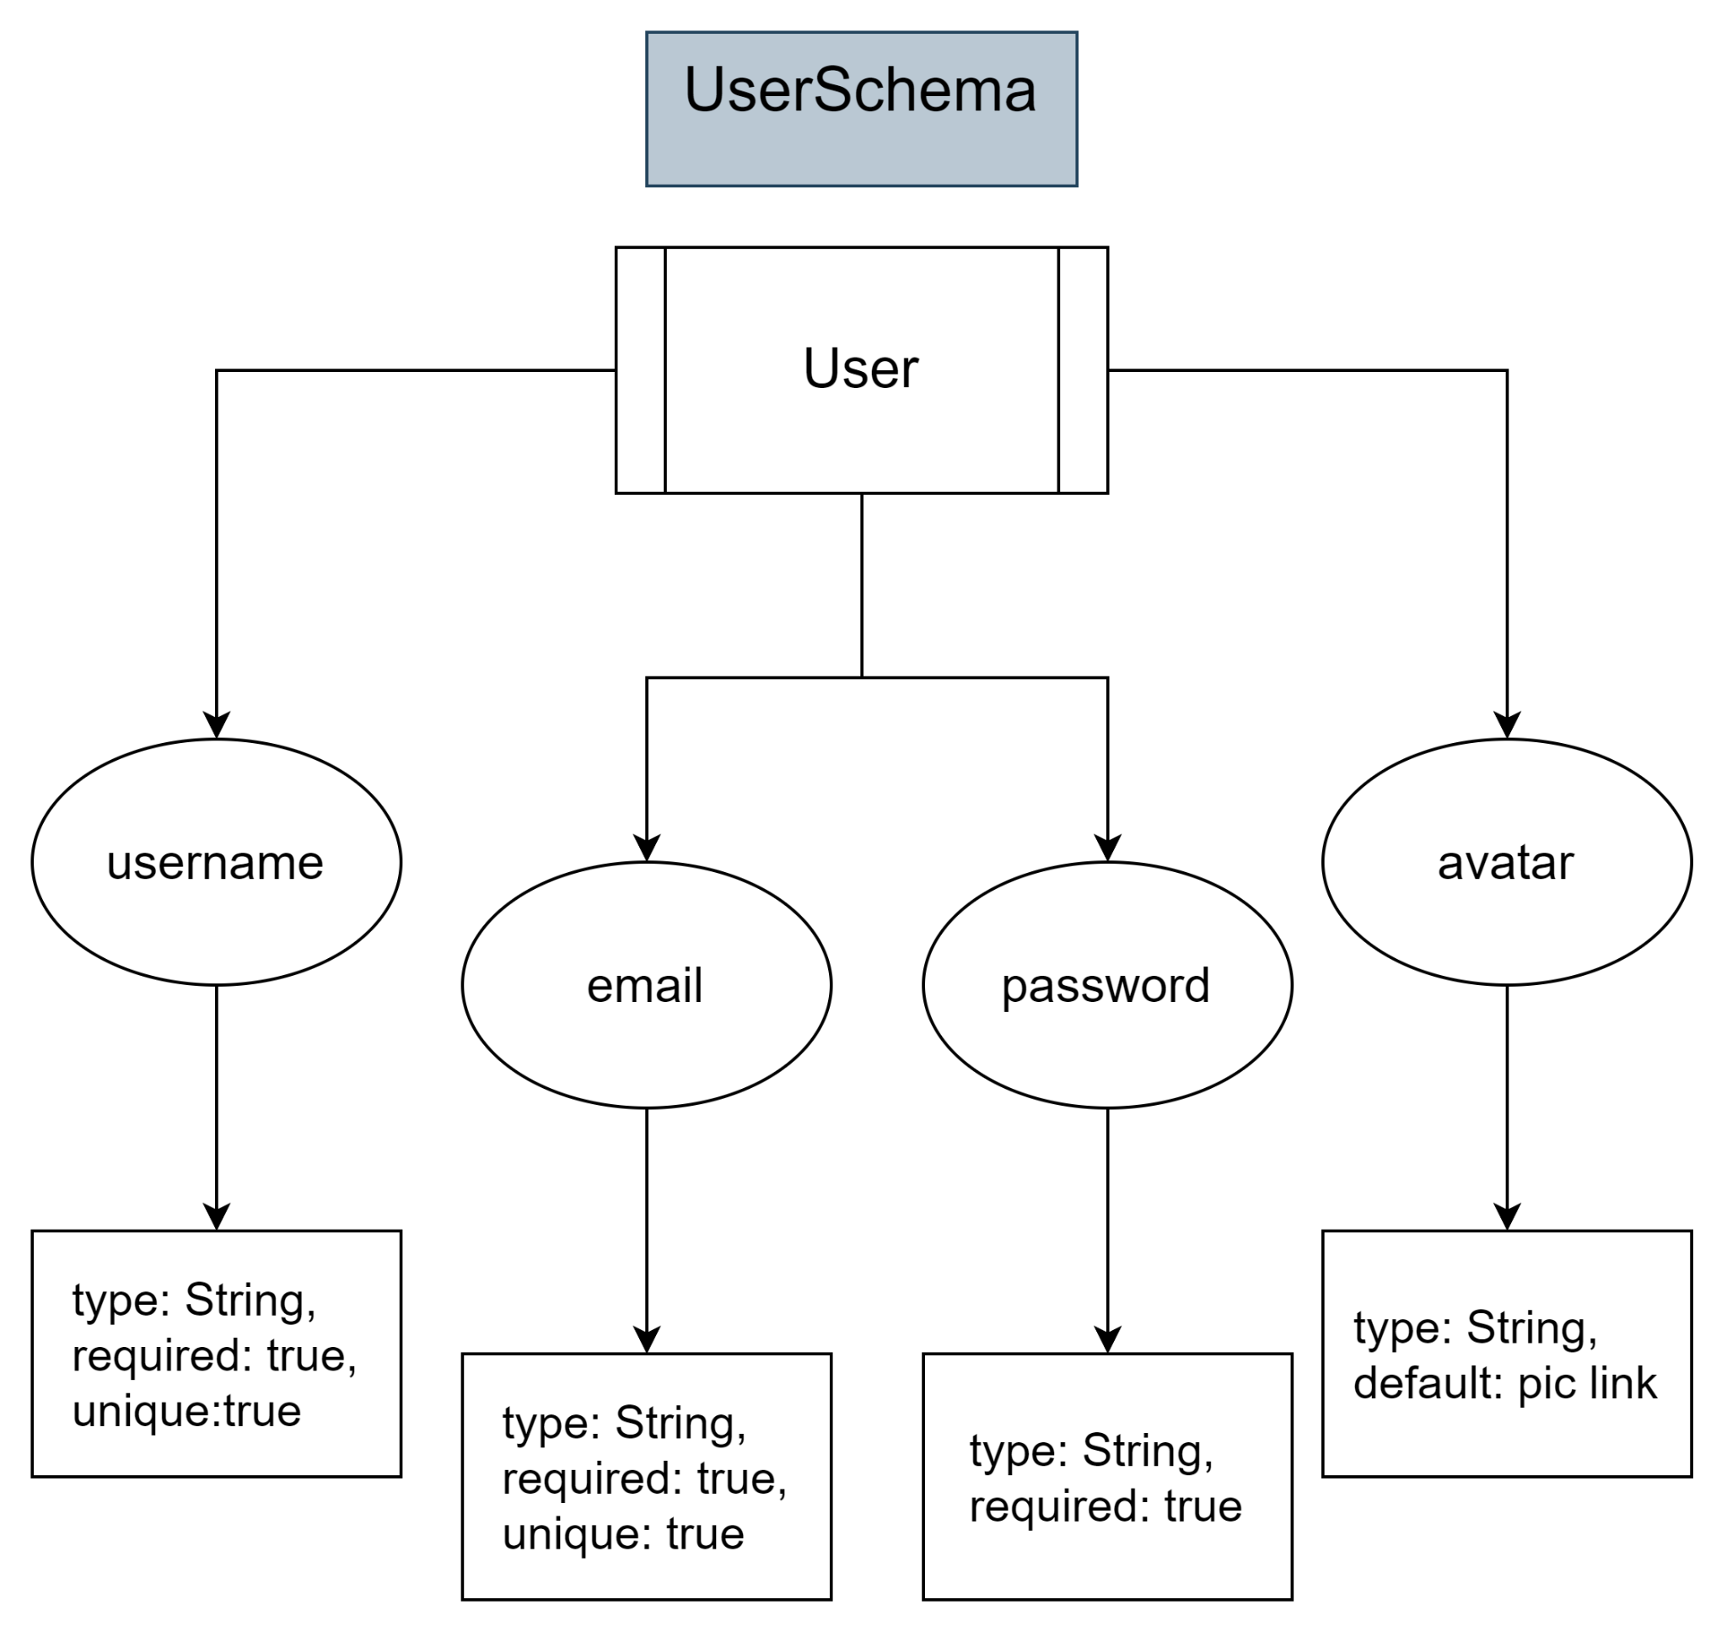

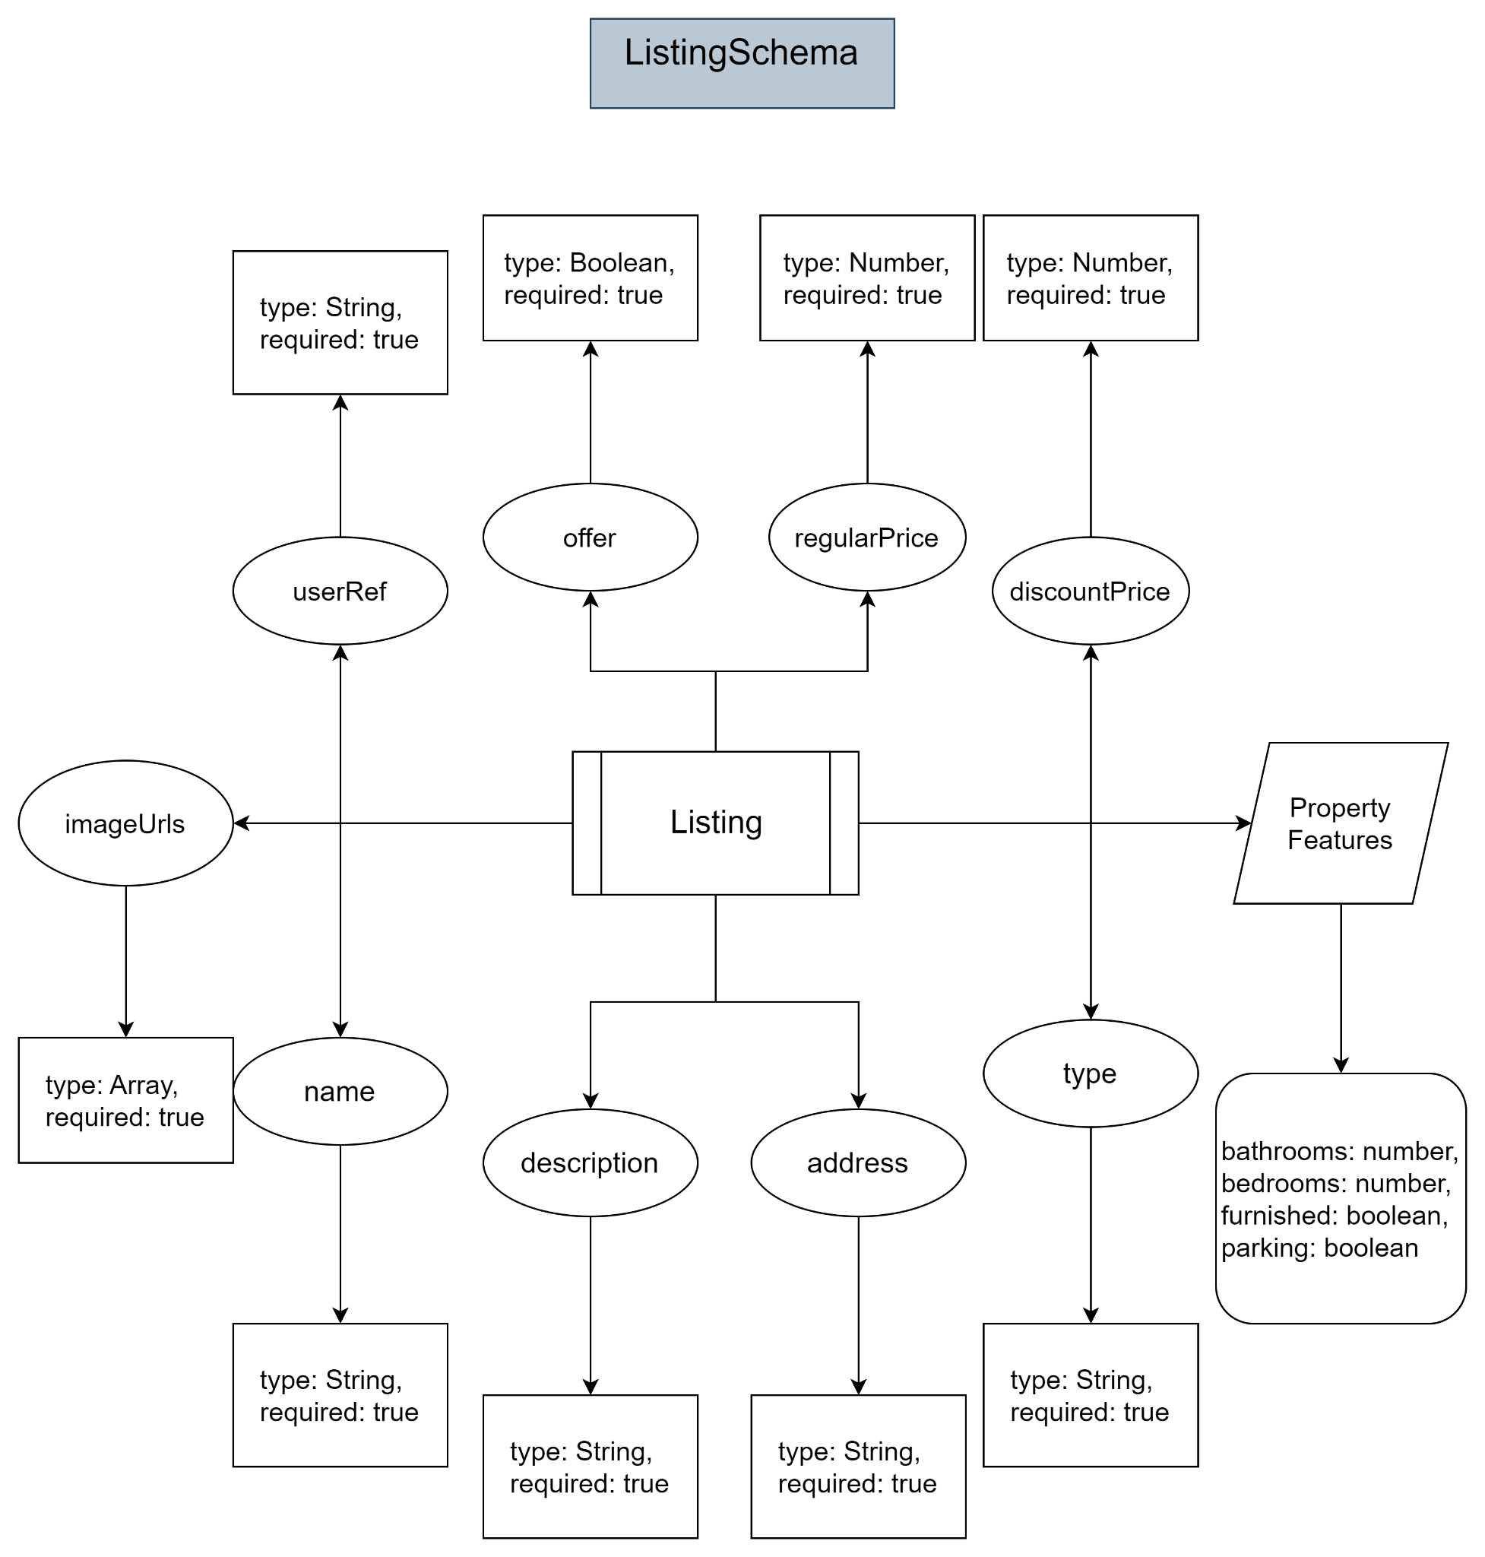

**API Design**

1. Auth

* `post/signup` → to signup a new account
* `post/signin` → to signin a existing account
* `post/google` → to signin/signup with Google
* `get/signout` → to signout from the account

1. Listing

* `post/create` → to create a new listing of property
* `delete/delete/:id` → to delete an existing property
* `post/update/:id` → to update an existing property
* `get/get/:id` → to get 1 property from listing according to ID
* `get/get` → to get all properties from listing

1. User

* `post/update/:id` → to update user info
* `delete/delete/:id` → to delete user
* `get/listing/:id` → to get the user’s listing of property
* `get/:id` → to get user

**Filtering Options**

1. **Search**

* Users can search for properties using a search bar, allowing them to input keywords, locations, or other relevant search terms.
* The search functionality will filter properties based on the entered query and display matching results in real time.

1. **Rent or Sell**

* Users can filter properties based on whether they are available for rent, for sale, or both.
* Checkboxes or dropdown menus will allow users to select their preferred option(s) for filtering.

1. **Price Sorting**

* Users can sort properties based on price, allowing them to view listings from high to low or low to high.
* Radio buttons or dropdown menus will enable users to choose their preferred sorting option.

**Implementation Details**

* The frontend will send filter criteria to the backend API, which will query the MongoDB database accordingly.
* Express.js routes will handle the filtering logic on the server side, fetching filtered results from the database.
* Axios will facilitate communication between the front end and backend, sending filter parameters and receiving filtered data.
* React components will dynamically render filtered property listings based on the received data.
* Redux will manage the application state, including the current filter settings and retrieved property data.

**Example Workflow**

* The user selects filtering options (e.g., rent, price high to low).
* Frontend sends filter criteria to the backend API.
* Express.js route processes the filter criteria and queries the MongoDB database for matching properties.
* Filtered property data is sent back to the frontend via Axios.
* React components dynamically render the filtered property listings based on the received data.
* The user views and interacts with the filtered property listings on the frontend, with Redux managing the application state.

